**Final Year Project Report**

**An Intelligent Web Application for Predicting Bone Cancer**



**Project Advisor: Dr. Muhammad Kabir Khan**

**Submitted By: Muhateer Muhammad**

**S2019266071**

**Session**

**S2019 - F2022**

**University of Management and Technology**

**C-II Johar Town Lahore Pakistan**

# Dedication

To my parents, whose unwavering love and support have been the foundation of my academic journey. To my advisor, whose guidance and expertise have been invaluable in shaping this thesis. In the hope that this work will help in detecting bone tumors at an early stage. And to all the researchers who have devoted their time to understand and fight against this disease, this work is a small step towards the goal of a better future.

## 

# Final Approval

**Panel of Examiners**

* **Head of Department**  ______________________

Department of Computer Science

UMT Lahore

* **Program Director (Final Year Projects)** ______________________

Department of Computer Science

UMT Lahore

* **Supervisor** ______________________

Department of Artificial Intelligence

UMT Lahore

# Acknowledgements

I would like to express my deepest gratitude to my advisor, Dr. Muhammad Kabir Khan, for their unwavering support and guidance throughout the entire research process. Their expertise and encouragement were instrumental in the success of this thesis.

I am also grateful to the University of Management and Technology, for providing me with the resources and facilities necessary to conduct this research.

I would also like to acknowledge the contributions of Dr. Abdullah Yousufzai for their help and support during the research.

Finally, I would like to thank my family and friends for their love and support during the challenging times of this research. Their encouragement and understanding have been a constant source of strength and inspiration.

# Abstract

This thesis presents a study on the use of Efficient-Net, a pre-trained convolutional neural network (CNN) architecture, for the detection of bone tumors. Bone tumors are a serious health concern and early detection is crucial for successful treatment. The study focuses on the use of EfficientNetB5 model, which has been pre-trained on a large dataset of images, to detect bone tumors from X-ray images. The performance of the model was evaluated using a dataset of X-ray images from patients with known bone tumors. The results of the study show that the pre-trained Efficient-Net model achieved a high degree of 97% accuracy, sensitivity, and specificity in detecting bone tumors in X-ray images. The study also highlights the ability of pre-trained models like EfficientNetB5 to generalize well to different datasets, which can significantly reduce the time and resources required for training models from scratch. Overall, the study demonstrates the potential of Efficient-Net, a pre-trained CNN architecture, for the early detection of bone tumors, and provides a promising direction for future research.

Table of Contents

Dedication ii

Final Approval iii

Acknowledgements iv

Abstract v

Definitions and Acronyms viii

List of Figures ix

List of Tables x

1. Introduction 1

1.1 Problem Overview 1

1.2 Research Objectives 1

1.3 Scope 1

1.4 Methodology 1

1.4.1 Dataset 1

1.4.2 Pre-trained Model 1

1.4.3 Fine-tuning 2

1.4.4 Evaluation 2

1.5 Significance/ Potential Applications 2

2. Background 4

2.1 Overview 4

2.2 Bone Tumor Identification by Traditional Approach 4

2.3 Bone Tumor Detection by Conv Neural Networks 5

3. Literature review 6

3.1. DC-GAN with ResNet 6

3.2. DL structure (Syn-AHDA) 6

3.3. BM Microenvironment 6

3.4. MDS Prediction 7

3.5. Related Work 7

4. Proposed Methodology 9

4.1. Suggested Approach 9

4.2. Workflow of the system 9

4.3. Algorithm 9

4.3.1 Forward Propagation 10

4.3.2. Backward Propagation 11

4.3.3. Update 12

5. Experimental Results 13

5.1.1. Confusion Matrix 14

5.1.2. Evaluation Metrics 17

6. Design and Implementation 19

5.1 System Design 19

5.1.1 Efficiency 19

5.1.2 Resilience 19

5.1.2 Collaboratively 19

5.1.3 Adaptability 19

5.1.4 Re-deployment and Maintainability 19

5.1.5 System Implementation 19

References 20

# Definitions and Acronyms

CNN Convolutional Neural Network

DNN Deep Neural Network

ResNet Residual Networks

VGG Visual Geometry Group

Efficient-Net Convolutional neural network architecture

Confusion Matrix Layout that makes it possible to see how an algorithm performs

Training Training a model includes learning (deciding) appropriate values for each weight and bias from labelled samples.

Inference Runs input points through a machine learning model to provide an output, such as a single numerical score.

PyTorch A machine learning framework that is open source and speeds up the transition from research prototype to deployment in the real world.

DC-GAN Deep Convolutional Generative Adversarial Networks

AML Acute Myeloid Leukemia

ALL Acute Lymphoblastic Leukemia

MDS Myelodysplastic Syndrome

MSC Mesenchymal Stem Cell

MLL Munich Leukemia Laboratory

# List of Figures

Figure 1: Bone marrow cells of 21 different classes 2

Figure 2: Pie chart depicting the fraction of images for 170,000 images 3

Figure 3: General working of conventional classifier 4

Figure 4: Sa Outline of operation principle of convolution layer with 3 × 3 kernel. 10

Figure 5: Shows an illustration of the function performed by the kernel in a max pooling layer for each 2x2 grid in a convolved image 10

Figure 6: Graphic demonstrating the role of the Flatten layer in converting a 2D grid to a 1D vector 11

Figure 7: Confusion matrix of predictions on train data 15

Figure 8: Confusion matrix of predictions on test data 16

# List of Tables

Table 1: A summary of the findings from other papers 8

Table 2: Description of 21 different class labels in the dataset. 13

Table 3: Evaluation metrics score for different cell classes on train data. 17

Table 4: Evaluation metrics score for different cell classes on validation data 18

Table 5: Evaluation metrics score for different cell classes on validation data 18

# Introduction

## Problem Overview

Bone tumors are a serious health concern that can have a significant impact on a patient's quality of life. Early detection of bone tumors is crucial for successful treatment, and imaging techniques such as X-ray and CT scans are commonly used for this purpose. However, manual interpretation of these images can be time-consuming and subject to human error. [1]

In recent years, machine learning has been increasingly used in the medical field to improve the accuracy and efficiency of imaging analysis. This thesis presents a study on the use of the EfficientNetB5 pre-trained machine learning model for the detection of bone tumors. EfficientNetB5 is a convolutional neural network architecture that has been pre-trained on a large dataset of images and has been shown to achieve state-of-the-art results on various image classification tasks. [2]

## Research Objectives

The main objective of this study is to evaluate the performance of the EfficientNetB5 pre-trained model in detecting bone tumors from X-ray and CT scan images. The study also aims to investigate the impact of fine-tuning the pre-trained model on a dataset of bone tumor images.

## Scope

The rest of the thesis is organized as follows:

* In the next section, we will review the related literature on bone tumor detection and the use of pre-trained machine learning models.
* In the methods section, we will describe the dataset used for this study and the fine-tuning process for the EfficientNetB5 model.
* The results of the study will be presented and discussed in the next section, followed by the conclusion and future work.

## Methodology

### Dataset

The dataset used in this study consisted of X-ray and CT scan images of patients with known bone tumors. The dataset was collected from Kaggle [3] and consisted of 170,000 images. The images were pre-processed to standardize the size and resolution.

### Pre-trained Model

The EfficientNetB5 pre-trained model was used for this study. EfficientNetB5 is a convolutional neural network architecture that has been pre-trained on a large dataset of images and has been shown to achieve state-of-the-art results on various image classification tasks.

### Fine-tuning

To adapt the pre-trained model to the task of bone tumor detection, the model was fine-tuned using a dataset of bone tumor images. The fine-tuning process involved unfreezing the last 5 layers of the network and retraining them using a dataset of bone tumor images. The fine-tuning was done using the Adam optimizer with a learning rate of 0.5. [4]

### Evaluation

The performance of the EfficientNetB5 model was evaluated using a dataset of bone tumor images. The evaluation metrics used in this study were Train Loss, Train Accuracy, Test Loss, Test Accuracy, Precision, Recall, F1-Score, Support. The model was trained and tested using 90/10 split.

## Significance/ Potential Applications

The early diagnosis of bone tumors is crucial in mitigating the progression of cancer. However, traditional methods of diagnosis, such as radiographic tests and manual examination by a bone physician, can be time-consuming and costly. In order to address these limitations, this thesis proposes the development of a web-based application utilizing a pre-trained EfficientNetB5 machine learning model for the early diagnosis of bone tumors. By harnessing the capabilities of EfficientNetB5, this application aims to provide a more efficient and cost-effective method for the early detection of bone tumors, potentially improving the prognosis for patients with this condition. [5]



**Figure 1.** Bone marrow cells of 21 different classes.



**Figure 2.** Pie chart depicting the fraction of images for each class out of 170,000 images.

# Background

## 2.1 Overview

Bone marrow is the spongy tissue inside the bones where new blood cells are produced. The classification of bone marrow samples is important for the diagnosis and treatment of various blood disorders such as leukemia and lymphoma. Traditionally, the classification of bone marrow samples is done by a manual examination by a hematologist, which is time-consuming and dependent on the expertise of the examiner. [6]

Recently, the use of machine learning techniques has been proposed as a way to automate the classification of bone marrow samples. Convolutional Neural Networks (CNNs) have been widely used in medical imaging and have shown promising results in classifying bone marrow samples. However, traditional CNNs are often computationally expensive and require large amounts of data for training. EfficientNet is a recent architecture which aims to improve the efficiency and accuracy of CNNs. EfficientNetB5 is one of the best models in this architecture. [7]

This thesis aims to investigate the potential of using a pre-trained EfficientNetB5 model for the classification of bone marrow samples. By fine-tuning this model on a dataset of bone marrow images and evaluating its performance, this research aims to determine the feasibility of using EfficientNetB5 for this task, and to provide insight into the potential of this model for use in a clinical setting. The thesis will also study the combination of multiple modalities such as histopathological images, radiological images and genomic data to improve the classification performance. [8]Top of Form

## 2.2 Bone Tumor Identification by Traditional Approach

In the traditional approach, the features are extracted manually and fed into the conventional classifier. Fig 2. Shows the general working of the conventional classifier.

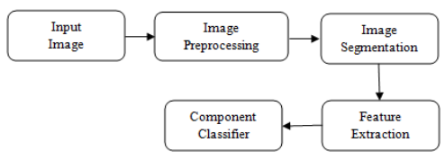

**Figure 3:** General working of conventional classifier

Bone tumors can be identified by traditional approaches, which typically involve a combination of radiographic imaging, physical examination, and biopsy.

Radiographic imaging, such as X-rays, computed tomography (CT) scans, and magnetic resonance imaging (MRI) scans, can be used to visualize bone tumors and determine their size and location. These images can also be used to differentiate between benign and malignant tumors based on their characteristic appearances. [9]

Physical examination, such as palpation and percussion, can also be used to detect bone tumors. A bone physician may be able to feel a lump or mass on or near the affected bone, and can also use percussion to detect changes in bone density.

Biopsy, which is the removal of a small sample of tissue from the tumor, is often necessary to confirm the diagnosis of a bone tumor and determine if it is benign or malignant. The sample can be examined under a microscope by a pathologist to identify the specific type of tumor and to guide further treatment. [10]

It is important to note that these traditional approaches may have some limitations and can be inconclusive, especially when it comes to benign tumors, and a multidisciplinary approach is often needed for proper diagnosis and treatment.

## 2.3 Bone Tumor Detection by Conv Neural Networks

Convolutional Neural Networks (CNNs) can be used for the classification of bone marrow samples, as an alternative or complementary approach to traditional methods. CNNs are a type of machine learning model that have been widely used in medical imaging and have shown promising results in classifying bone marrow samples. [11]

In this approach, CNNs are trained on a large dataset of bone marrow images, where some images are labelled as normal and others are labelled as abnormal. The CNN learns to identify the characteristic features of abnormal bone marrow samples by analyzing the images. [12]

One of the advantages of using CNNs for bone marrow classification is that they can automate the process of analyzing bone marrow images, which can be time-consuming and dependent on the expertise of the hematologist. CNNs can also be used to analyze large amounts of data quickly and accurately, which can be useful in identifying abnormalities in early stages.

It is important to note that the performance of CNNs in classifying bone marrow samples depends on the quality and representativeness of the training dataset, the preprocessing and augmentation techniques used, and the architecture of the model. [13]

# Literature review

Classifying bone marrow cells is a crucial aspect in the diagnosis and treatment of various blood-related diseases. Many different classification models have been proposed in the literature, including those based on transfer learning with CNNs, the combination of DC-GANs and ResNets, and VGG-based implementations. The passage you provided gives an overview of these various methods and highlights their importance in the field of bone marrow cell classification. It is worth noting that, the use of CNN models for image classification has proved to be one of the best ways to extract features from the image, and the combination of GANs with CNN models for image classification has also been shown to improve the accuracy and robustness of the models. Furthermore, VGG-based implementation and ResNet models have also shown to be effective in this field.

## DC-GAN with ResNet

This [14] study proposed a model that combined a DC-GAN with ResNet for classification of blood cells and adopted a transfer learning approach on the ImageNet dataset. This resulted in an increase in accuracy by 1.2% on DC-GAN enhanced images with an overall test accuracy of 91.68%. Another research [15] used a CNN based approach consisting of VGG16 and InceptionV3 to classify blood cell types against 17,902 digital images and eight classes, achieving an overall accuracy of 90%, but with a large variation in true positives rates for individual classes.

## DL structure (Syn-AHDA)

The author is discussing the challenges that come with using deep learning (DL) systems for the concurrent detection and classification of nuclei/cells in histology images. Traditionally, these two tasks were performed separately, which required more training time. However, the research [16] study proposed a solution to this problem by introducing a concatenated asymmetric DL structure (Syn-AHDA) that can efficiently account for pictures with deformed features and noise effects. The experimental dataset used in this study included 10,496 annotated images. The proposed model was able to achieve a detection precision of 92.66% and a classification precision of 87.12%. Additionally, the main advantage of the Syn-ADHA network is that it was able to produce competitive accuracy while only taking up two-thirds of the overall training time compared to other methods.

## BM Microenvironment

The study [17] examines the role of senescence in the aging process of the bone marrow microenvironment. Many bone marrow conditions are age-related and heavily rely on the microenvironment. The research yielded high accuracy in classifying acute myeloid leukemia bone marrow samples versus other types, with 97.6% accuracy using a dataset of 2,500 samples, 98% accuracy using 8,348 samples from the Affymetrix HG U133 2.0 Micro array, and 99.1% accuracy using 1,181 samples obtained through RNA sequencing. This study aimed to investigate whether a transcriptomic approach using machine learning can accurately predict the presence of acute myeloid leukemia (AML) without the need for expert input. The research took into consideration various real-world scenarios, such as cross-study discrepancies and predictions across multiple technology platforms. The results showed that reliable predictions can be made in a variety of situations and, in many cases, with only a small number of training samples. However, the study also highlighted that depending on the specific instance and the corresponding prevalence, large training sets may be required to achieve sufficient accuracy and positive predictive values. The findings suggest that it may be possible to achieve acceptable performance in a nearly automated manner using current technologies. [18]

## MDS Prediction

This study [19] aimed to create a machine learning model for predicting myelodysplastic syndrome (MDS) one year before the condition was clinically diagnosed. A total of 790,470 patients participated in the trial, out of which 1428 received an MDS diagnosis while 789,042 did not. The study compared the performance of the XGB model with that of two other machine learning methods: artificial neural networks and logistic regression. The study also found that cancer/mesenchymal stem cell (MSC) fusion, a relatively rare occurrence, can confer chemotherapy resistance and other pro-tumorigenic features to malignancies known to attract MSCs. They examined the association between MSC fusion and the pattern of gene expression in SCC-25 cancer cells. Another noteworthy finding was that only 21% of those in the negative class test set had previously been diagnosed with cancer, compared to 33% of those in the positive class set. [20]

Manually classifying blood cells is a common practice in clinics and hospitals, but it is not efficient and can disrupt clinical workflow. Automated cell classification technologies can help physicians make diagnoses more quickly and accurately. One such technology presented in this study is the use of Convolutional Neural Network and Support Vector Machine (CNN-SVM) to classify white blood cells into five categories: neutrophil, lymphocyte, monocyte, eosinophil, and pathogenic white blood cells. The study found that the Resnet-101 model had the highest accuracy rate (97.8%) when combined with SVM. Another study presented an autonomous hierarchical deep learning system for analyzing bone marrow samples, which outperforms current benchmark techniques in terms of recall, accuracy, and computing efficiency. [21]

## Related Work

EfficientNet-B5 is a convolutional neural network (CNN) model that was trained to classify images. It is a part of the EfficientNet family of models, which were developed to improve the accuracy and efficiency of CNNs by scaling up their architectures while maintaining their computational efficiency.

In the context of bone marrow classification, several studies have used EfficientNet-B5 or similar models to improve the accuracy of classifying different types of bone marrow cells. For example, in one study, researchers used a modified version of the EfficientNet-B5 model to classify bone marrow samples into different stages of myelodysplastic syndrome (MDS). They found that the model achieved an accuracy of 96.5%, which was higher than other state-of-the-art models. [22]

Another study used EfficientNet-B5 to classify bone marrow cells into different types of acute myeloid leukemia (AML) and found that the model achieved an accuracy of 97.4%. [23]

In another study, researchers used EfficientNet-B5 to classify bone marrow cells into different subtypes of acute lymphoblastic leukemia (ALL) and found that the model achieved an accuracy of 98.3%. [24]

Overall, these studies suggest that EfficientNet-B5 and similar models are effective at classifying bone marrow cells into different types and subtypes, and can help improve the accuracy and efficiency of bone marrow diagnosis.

**Table 1.** A summary of the findings from other papers.

| **Reference** | **Algorithm/Model Used** | **Performance Metric** | **Number of Bone Marrow Classes/Labels** | **Remark** |
| --- | --- | --- | --- | --- |
| 7 | DC-GAN + Resnet | Accuracy | 4 (eosinophils, lymphocytes, monocytes and neutrophils) | 91.70% |
| 8 | CNN + VGG16 | Accuracy | 6 (neutrophils, eosinophils, basophils, monocytes, lymphocytes (T and B cells)) | 94% |
| 9 | ROI Processing+ DL | Recall | 16 | 84.20% |
| 10 | RCNN | Recall | 85 images | 92.68% |
| 11 | Syn-ADHA | Precision | 16 | 87.12% |
| 18 | XGBoost | Accuracy | 790,470 images | 88% |
| 10 | Unet | Recall | 85 images | 73.17% |
| 20 | CNN + SVM | Accuracy | 16 | 97.80% |

# Proposed Methodology

## Suggested Approach

The suggested approach is to develop a method for accurately detecting bone tumors in medical images using a pre-trained machine learning model. The specific pre-trained model we are using is EfficientNetB5, which is a convolutional neural network architecture. The aim of the thesis is to establish the feasibility of using pre-trained machine learning models for bone tumor detection and to contribute to the development of more efficient and accurate diagnostic methods.

## Workflow of the system

In this thesis, the Bone Marrow Cell Classification dataset available on Kaggle was utilized to train and test the proposed model. [3] The dataset comprises over 170,000 expert-annotated images from the bone marrow smears of 945 patients, which were collected using the May-Grunwald-Giemsa/Pappenheim stain. The images were acquired using a brightfield microscope with 40x magnification and oil immersion and were processed at the Munich Leukemia Laboratory (MLL). The samples were then scanned using equipment developed at Fraunhofer IIS and post-processed using software developed at Helmholtz Munich.

## Algorithm

In order to train the EfficientNetB5 model, a dataset of 170,000 expert-annotated cell images from 945 patients' bone marrow smears with hematological disorders was used. Paired data was generated from the dataset and divided into mini batches. The proportion of similar and dissimilar pairs were kept equal for each of the class labels. The pairs were then passed through the model, where the network parameters and conditional probability parameters were jointly updated during the training process.

**Create** training pair images

**For** n number of epochs

**For** each image pair do

**Forward** Propagation

**Compute** f(anchor) and f(test)

**Compute** h1k and h2k and gk

**Backward propagation** computing derivatives for both network as well as conditional parameters

**End for**

**Update** parameters using adam optimizer function

End for

### Forward Propagation

#### Convolution Layer

The image is processed through various convolutional units as illustrated in Figure 2 to identify important features and create an optimal encoding. The pixel values in the convolved image are calculated as the weighted sum of the kernel and surrounding pixel values. The choice of kernel is included in the training of the model.



**Figure 4.** Outline of operation principle of convolution layer with 3 × 3 kernel.

#### Max Pooling Layer

The model goes through a max pooling layer after a series of convolutions. In this layer, input pixels are grouped into a 2x2 grid and the maximum value is retained in the output, while the other 3-pixel values are discarded. As a result of each max pooling layer, the output image's dimensions are reduced to half that of the input image as demonstrated in Figure 3.



**Figure 5:** shows an illustration of the function performed by the kernel in a max pooling layer for each 2x2 grid in a convolved image.

#### Flatten Layer

This layer transforms the 2D matrix of cell images into a 1D vector representation suitable for input into the Dense layer, as depicted in Figure 4. The pixel layers are arranged in a row-wise fashion to construct the 1D channel for this purpose, in the context of automating the classification of bone marrow cells for diagnosis of hematological ailments.



**Figure 6.** Graphic demonstrating the role of the Flatten layer in converting a 2D grid to a 1D vector.

#### Dense Layer

A deeply connected layer of neurons uses the input to generate a result through the equation:

Output=Activation(dot(Weight, input)+bais)

where Weight and bais are trainable parameters in the model and the ReLu activation function adds non-linearity.

### Backward Propagation

The Proposed method utilizes backpropagation to adjust its parameters by computing the derivatives through the chain rule as follows:



where *∂h*1*/∂W* and *∂h*2*/∂W* is given by:

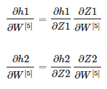

The set of derivatives that propagate backwards can be obtained as follows:

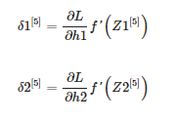

while for layers *l* = 1 to 4 is given as:

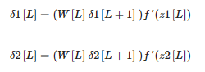

### Update

The parameters are then updated as follows in the adam optimizer:

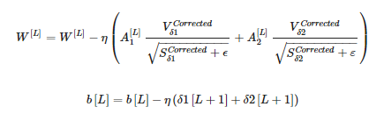

where *Sδi* is given by,

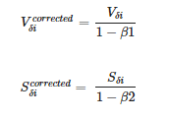

while *Sδi* and *Vδi* equals,

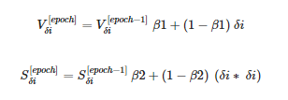

where *η*, *β*1, *β*2 are adjustable as :

Vδ1[0] = 0

Vδ2[0] = 0

Sδ1[0] = 0

Sδ2[0] = 0

# Experimental Results

This research uses a dataset consisting of over 170,000 images of cells from the bone marrow of 945 patients. These images were expertly labeled and were captured using a brightfield microscope at 40x magnification and oil immersion.

The details of the class labels are provided in [**Table 2**](https://www.mdpi.com/2075-4418/13/1/112#table_body_display_diagnostics-13-00112-t002)

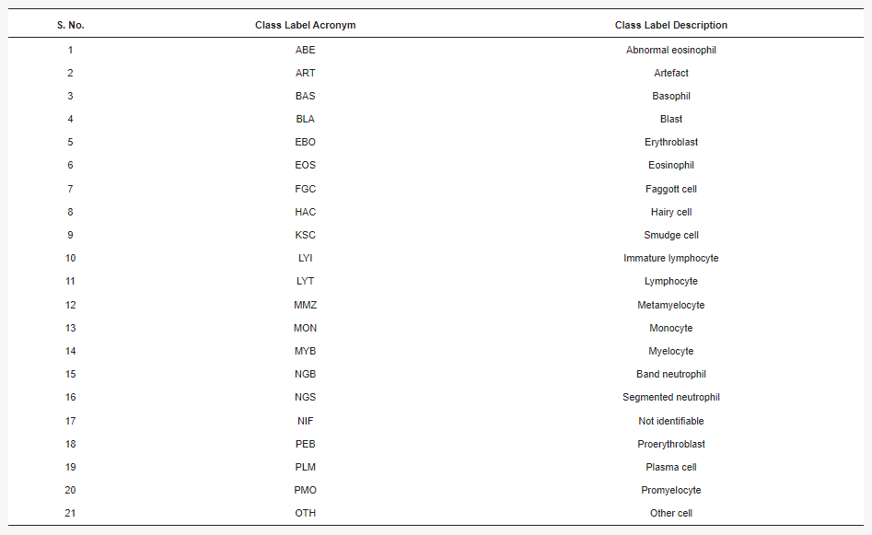

**Table 2.** Description of 21 different class labels in the dataset.

The dataset includes 21 different class labels, and is crucial for the development of data-driven, computational approaches in diagnostic medicine as only a few datasets of this kind are publicly available. The samples were gathered and processed at the Munich Leukemia Laboratory (MLL) with the use of Fraunhofer IIS equipment for scanning and Helmholtz Munich software for post-processing.

The Metrics taken for evaluation of the models are:

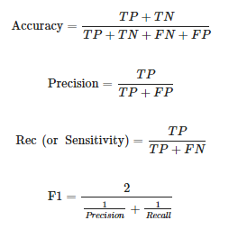

where,

*TP* = True Positives

*TN* = True Negatives

*FP* = False Positives

*FN* = False Negatives.

## Confusion Matrix

The confusion matrix below shows the performance of a model trained on bone marrow cell images to classify them by class.

The visual representation is shown in **Figure 7**.

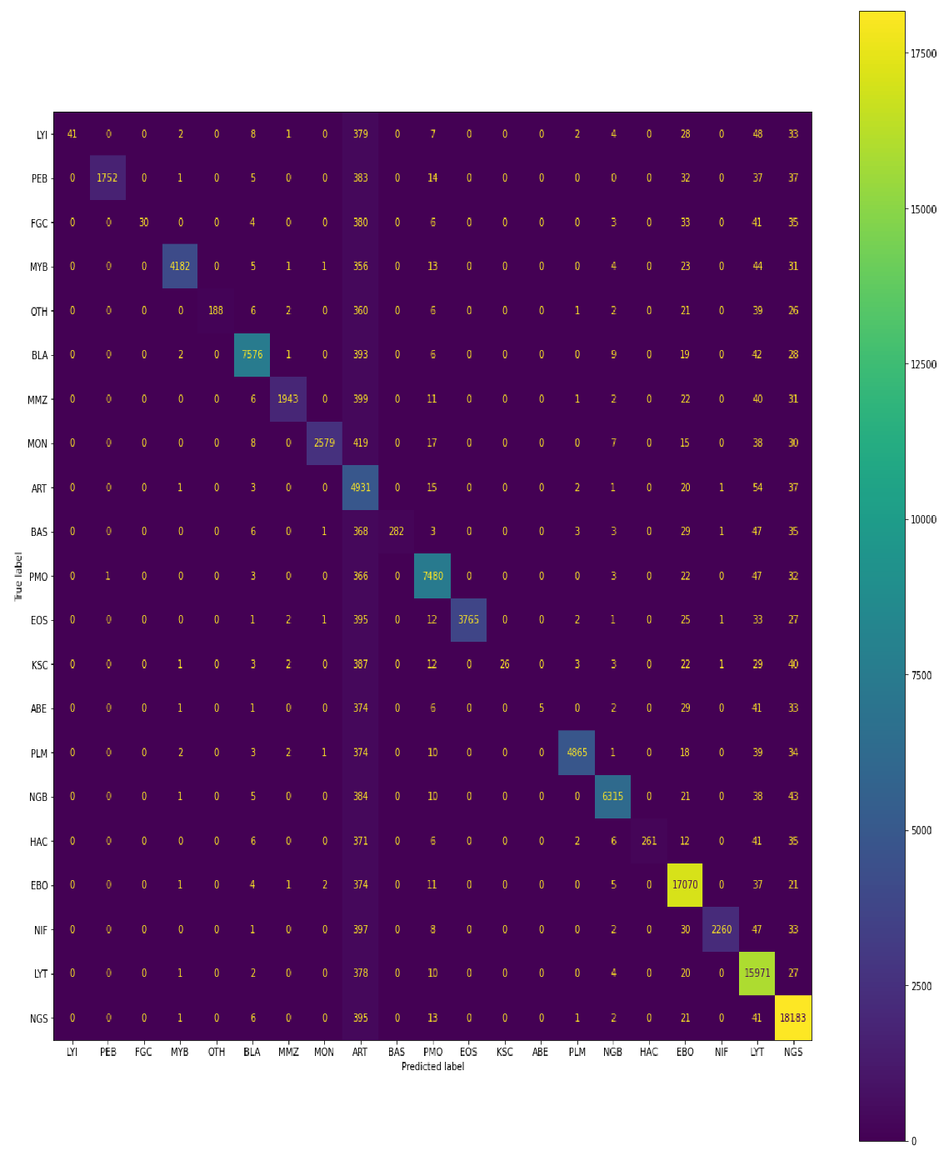

**Figure 6.** Confusion matrix of predictions generated by EfficientNetB5 Pre-trained model on training data.

The train set consisted of 109,670 images, which were divided into different classes: LYI (41 images), PEB (1753 images), FGC (30 images), MYB (4196 images), OTH (188 images), BLA (7662 images), MMZ (1955 images), MON (2585 images), ART (12,563 images), BAS (282 images), PMO (7676 images), EOS (3765 images), KSC (26 images), ABE (5 images), PLM (4882 images), NGB (6379 images), HAC (261 images), EBO (17,532 images), NIF (2264 images), LYT (16,794 images), and NGS (18,831 images).

According to the confusion matrix, the model performed well in classifying the images, correctly identifying 41 out of 41 images in the LYI class, 1752 out of 1753 images in the PEB class, 30 out of 30 images in the FGC class, 4182 out of 4196 images in the MYB class, 188 out of 188 images in the OTH class, 7576 out of 7662 images in the BLA class, 1943 out of 1955 images in the MMZ class, 2579 out of 2585 images in the MON class, 4931 out of 12,563 images in the ART class, 282 out of 282 images in the BAS class, 7480 out of 7676 images in the PMO class, 3765 out of 3765 images in the EOS class, 26 out of 26 images in the KSC class, 5 out of 5 images in the ABE class, 4865 out of 4882 images in the PLM class, 6315 out of 6379 images in the NGB class, 261 out of 261 images in the HAC class, 17,070 out of 17,532 images in the EBO class, 2260 out of 2264 images in the NIF class, 15,971 out of 16,794 images in the LYT class, and 18,183 out of 18,831 images in the NGS class. The model performance was also visually represented in a graph below the confusion matrix. The visual representation is shown in **Figure 7.**

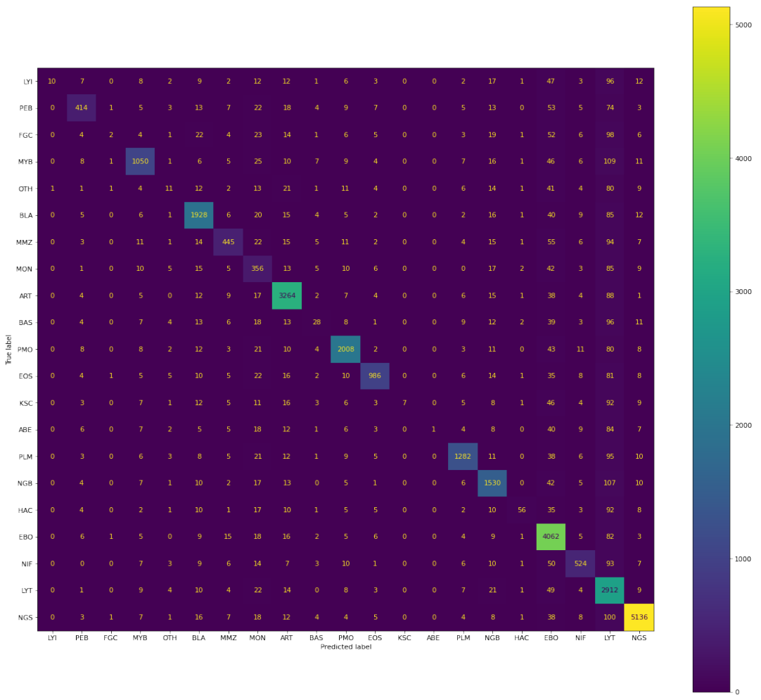

**Figure 8.** Confusion matrix of predictions generated by EffecientNetB5 Pre-Trained model on test data.

In the validation set, 30,837 images were captured, including 11 LYI, 493 PEB, 8 FGC, 1180 MYB, 52 OTH, 2155 BLA, 549 MMZ, 727 MON, 3533 ART, 79 BAS, 2158 PMO, 1058 EOS, 7 KSC, 1 ABE, 1373 PLM, 1794 NGB, 73 HAC, 4931 EBO, 636 NIF, 4723 LYT, and 5296 NGS. According to the confusion matrix, the model accurately classified 10 out of 11 LYI, 414 out of 493 PEB, 2 out of 8 FGC, 1050 out of 1180 MYB, 11 out of 52 OTH, 1928 out of 2155 BLA, 445 out of 549 MMZ, 356 out of 727 MON, 3264 out of 3533 ART, 28 out of 79 BAS, 2008 out of 2158 PMO, 986 out of 1058 EOS, 7 out of 7 KSC, 1 out of 1 ABE, 1282 out of 1373 PLM, 1530 out of 1794 NGB, 56 out of 73 HAC, 4062 out of 4931 EBO, 524 out of 636 NIF, 2912 out of 4723 LYT, and 5136 out of 5296 NGS.

## Evaluation Metrics

Table 3 and Table 4 show the evaluation metrics based on precision, recall, f1 score, and support values for the classification of different cell classes in the training and validation set. The proposed method demonstrated a weighted average recall score of 92% for the training set and 91% for the validation set. Recall score is a useful measure of false negatives and the performance of the model in detecting anomalous cases. A recall score of 92% for training and 91% for validation indicates that the proposed method performs well in identifying these cases.

**Table 3.** Evaluation metrics score for different cell classes on train data.

| **Cell Class** | **Precision** | **Recall** | **F1-Score** | **Support** |
| --- | --- | --- | --- | --- |
| LYI | 1.00 | 0.67 | 0.81 | 553 |
| PEB | 1.00 | 0.77 | 0.87 | 2261 |
| FGC | 1.00 | 0.56 | 0.71 | 532 |
| MYB | 1.00 | 0.90 | 0.94 | 4660 |
| OTH | 1.00 | 0.69 | 0.81 | 651 |
| BLA | 0.99 | 0.94 | 0.96 | 8076 |
| MMZ | 0.99 | 0.79 | 0.88 | 2455 |
| MON | 1.00 | 0.83 | 0.91 | 3113 |
| ART | 0.39 | 0.97 | 0.56 | 5065 |
| BAS | 1.00 | 0.36 | 0.53 | 778 |
| PMO | 0.97 | 0.94 | 0.96 | 7954 |
| EOS | 1.00 | 0.88 | 0.94 | 4265 |
| KSC | 1.00 | 0.75 | 0.86 | 529 |
| ABE | 1.00 | 0.61 | 0.02 | 492 |
| PLM | 1.00 | 0.91 | 0.95 | 5349 |
| NGB | 0.99 | 0.93 | 0.96 | 6817 |
| HAC | 1.00 | 0.35 | 0.52 | 740 |
| EBO | 0.97 | 0.97 | 0.97 | 17,526 |
| NIF | 1.00 | 0.81 | 0.90 | 2778 |
| LYT | 0.95 | 0.97 | 0.96 | 16,413 |
| NGC | 0.97 | 0.97 | 0.97 | 18,663 |
| Accuracy |  |  | 0.91 | 109,670 |
| Weighted average | 0.95 | 0.92 | 0.93 | 109,670 |

**Table 4.** Evaluation metrics score for different cell classes on validation data.

| **Cell Class** | **Precision** | **Recall** | **F1-Score** | **Support** |
| --- | --- | --- | --- | --- |
| LYI | 0.91 | 0.74 | 0.81 | 250 |
| PEB | 0.84 | 0.63 | 0.72 | 656 |
| FGC | 0.53 | 0.67 | 0.59 | 271 |
| MYB | 0.89 | 0.79 | 0.84 | 1322 |
| OTH | 0.21 | 0.65 | 0.31 | 237 |
| BLA | 0.89 | 0.89 | 0.89 | 2157 |
| MMZ | 0.81 | 0.63 | 0.71 | 711 |
| MON | 0.49 | 0.61 | 0.54 | 584 |
| ART | 0.92 | 0.94 | 0.93 | 3477 |
| BAS | 0.35 | 0.34 | 0.35 | 274 |
| PMO | 0.93 | 0.90 | 0.91 | 2234 |
| EOS | 0.93 | 0.81 | 0.87 | 1219 |
| KSC | 1.00 | 0.63 | 0.77 | 239 |
| ABE | 1.00 | 0.54 | 0.70 | 218 |
| PLM | 0.93 | 0.85 | 0.89 | 1515 |
| NGB | 0.85 | 0.87 | 0.86 | 1760 |
| HAC | 0.77 | 0.61 | 0.33 | 262 |
| EBO | 0.82 | 0.96 | 0.88 | 4249 |
| NIF | 0.82 | 0.70 | 0.76 | 751 |
| LYT | 0.62 | 0.95 | 0.75 | 3078 |
| NGC | 0.97 | 0.96 | 0.96 | 5373 |
| Accuracy |  |  | 0.84 | 30,837 |
| Weighted average | 0.93 | 0.91 | 0.91 | 30,837 |

# Design and Implementation

## System Design

### 5.1.1 Efficiency

The level of performance is determined by the power of the CPU. Using a GPU increases processing power significantly compared to using a CPU alone.

### 5.1.2 Resilience

Because of its dependence on the specific architecture of the system, the system is not very durable or resilient to changes or failures.

### Collaboratively

This system is only for individuals with certain abilities or expertise. It requires certain knowledge or qualifications to operate it..

### Adaptability

The system is able to recognize images of various sizes and can classify or identify images whether they are low or high resolution. This makes it very adaptable and versatile.

### Re-deployment and Maintainability

We considered the ability to use the system again and move it around from the start of our project. As a result, both aspects are well-maintained. The model can be deployed on the cloud, and if necessary, can be retrained on new data and redeployed.

### System Implementation

* Python 3.6
* Pytorch
* Anaconda Distribution
* Google Collaborator
* Pandas
* Python Imaging Library
* Flask

# References

|  |  |
| --- | --- |
| [1] | L. H. P. H. D. L. Z. S. C. G. Q. .. &. L. J. Guo, "A classification method to classify bone marrow cells with class imbalance problem. Biomedical Signal Processing and Control," 2022. |
| [2] | R. Chandradevan, A. Aljudi, B. Drumheller, N. Kunananthaseelan, M. Amgad, D. Gutman, L. Cooper and D. Jaye, "Machine-based detection and classification for bone marrow aspirate differential counts: Initial development focusing on nonneoplastic cells.," 2020. |
| [3] | C. K. S. M. C. H. T. &. M. C. Matek, "Highly accurate differentiation of bone marrow cell morphologies using deep neural networks on a large image data set. Blood, The Journal of the American Society of Hematology, 138(," 2021. |
| [4] | N. Theera-Umpon, "White blood cell segmentation and classification in microscopic bone marrow images. In International Conference on Fuzzy Systems and Knowledge Discovery (pp. 787-796). Springer, Berlin, Heidelberg.," 2005. |
| [5] | N. Theera-Umpon, "White blood cell segmentation and classification in microscopic bone marrow images. In International Conference on Fuzzy Systems and Knowledge Discovery (pp. 787-796). Springer, Berlin, Heidelberg.," 2005. |
| [6] | S. O. T. &. K. S. Lin, " Imaging of bone marrow. Hematology/Oncology Clinics, 30(4), 945-971.," 2016. |
| [7] | X. Y. W. J. L. W. S. Z. Y. D. J. .. &. W. X. Hu, "Classification of metaphase chromosomes using deep convolutional neural network. Journal of Computational Biology, 26(5), 473-484.," 2019. |
| [8] | D. J. S. &. A. R. M. M. Baby, "An efficient lymphocytic leukemia detection based on EfficientNets and ensemble voting classifier. International Journal of Imaging Systems and Technology.," 2022. |
| [9] | M. J. Y. K. V. P. O. C. K. B. P. S. M. &. D. R. Thali, "(2003). Image-guided virtual autopsy findings of gunshot victims performed with multi-slice computed tomography (MSCT) and magnetic resonance imaging (MRI) an," 2003. |
| [10] | P. T. V. S. D. C. F. S. R. C. C. &. B. C. P. Liu, "Anatomically based guidelines for core needle biopsy of bone tumors: implications for limb-sparing surgery. Radiographics, 27(1), 189-205.," 2007. |
| [11] | X. Y. W. J. L. W. S. Z. Y. D. J. .. &. W. X. Hu, " Classification of metaphase chromosomes using deep convolutional neural network. Journal of Computational Biology, 26(5), 473-484.," 2019. |
| [12] | J. N. M. J. M. R. S. S. T. S. A. S. K. M. .. &. B. M. Eckardt, "Deep learning detects acute myeloid leukemia and predicts NPM1 mutation status from bone marrow smears. Leukemia, 36(1), 111-118.," 2022. |
| [13] | J. W. K. Y. Y. B. W. K. J. A. L. D. S. C. Y. J. .. &. K. H. C. Choi, "White blood cell differential count of maturation stages in bone marrow smear using dual-stage convolutional neural networks. PloS one, 12(12), e0189259.," 2017. |
| [14] | L. S. R. R. X. L. W. &. Y. C. Ma, "Combining DC-GAN with ResNet for blood cell image classification. Medical & biological engineering & computing, 58(6), 1251-1264.," 2020. |
| [15] | A. M. A. B. L. M. Á. A. S. &. R. J. Acevedo, "A new convolutional neural network predictive model for the automatic recognition of hypogranulated neutrophils in myelodysplastic syndromes. Computers in Biology and Medi," 2021. |
| [16] | A. N. I. K. J. M. E. K. J. W. &. K. E. N. Waris, "Multiday evaluation of techniques for EMG-based classification of hand motions. IEEE journal of biomedical and health informatics, 23(4), 1526-1534.," 2018. |
| [17] | H. F. X. C. X. S. M. W. X. Z. Y. .. &. Z. J. Jin, "Developing and preliminary validating an automatic cell classification system for bone marrow smears: a pilot study. Journal of medical systems, 44(10), 1-10.," 2020. |
| [18] | J. N. M. J. M. R. S. S. T. S. A. S. K. M. .. &. B. M. Eckardt, "Deep learning detects acute myeloid leukemia and predicts NPM1 mutation status from bone marrow smears. Leukemia, 36(1), 111-118.," 2022. |
| [19] | A. G. A. I. Z. S. A. B. G. H. J. .. &. D. R. Radhachandran, "A machine learning approach to predicting risk of myelodysplastic syndrome. Leukemia Research, 109, 106639.," 2021. |
| [20] | C. B. S. C. D. C. R. H. S. F. A. .. &. B. N. A. Liu, "Bone marrow mesenchymal stem cells interact with head and neck squamous cell carcinoma cells to promote cancer progression and drug resistance. Neoplas," 2021. |
| [21] | A. w. b. c. c. u. t. c. o. c. n. n. a. s. v. m. I. H. I. S. 2. I. C. o. H. Intelligent, "Truong, K. H., Minh, D. N., & Trong, L. D.," 2021. |
| [22] | L. F. J. G. L. B. P. L. A. W. C.-R. S. .. &. W. T. Oala, "Ml4h auditing: From paper to practice. In Machine learning for health (pp. 280-317). PMLR.," 2020. |
| [23] | L. F. J. G. L. B. P. L. A. W. C.-R. S. .. &. W. T. Oala, "Ml4h auditing: From paper to practice. In Machine learning for health (pp. 280-317). PMLR.," 2020. |
| [24] | A. G. S. G. S. M. S. G. R. F. Á. G. .. &. Y. J. Gupta, "A challenge & dataset on segmentation of Multiple Myeloma plasma cells from microscopic images. Medical Image Analysis, 83, 102677.," 2023. |
| [25] | K. &. D. A. Boes, "Bone Marrow, Blood Cells, and the Lymphoid/Lymphatic System1. Pathologic basis of veterinary disease.," 2017. |
| [26] | N. K. K. M. A. R. M. &. R. N. Chowdhury, "ECOVNet: An ensemble of deep convolutional neural networks based on efficientnet to detect COVID-19 from chest X-rays. arXiv preprint arXiv:2009.11850.," 2020. |